**Competence Document**

**Shallwin Silvania**

1. **Persona**

My name is Shallwin Silvania, I come from Aruba. This will be my second year in the Netherlands. My social skills are not the best but I’m working on them. What I lack in socialization skills, I make up in my affinity in my arts. I don’t believe in hand-outs and always strive for perfection (even though sometimes it isn’t physically possible to achieve). My determination is fueled by those who are in need, so if I can make a change in the world for the better, best believe I will do anything in my power to make that change. It’s my dream to create or at least pioneer the creation of embedded quantum chips but alas this isn’t a research university, and I wouldn’t like to waste too much time (on something that will probably never get recognized) seeing that I usually get carried away when researching a topic. My hobbies include Tinkering (making small gadgets mostly with ESP), Language learning and Violin (as of 2 months ago). My complete study route is as follows MAVO (1 year) – HAVO (4 years) – AFY at University of Aruba (1 year) – HBO ICT at Fontys University of Applied Sciences (1 year and counting ).

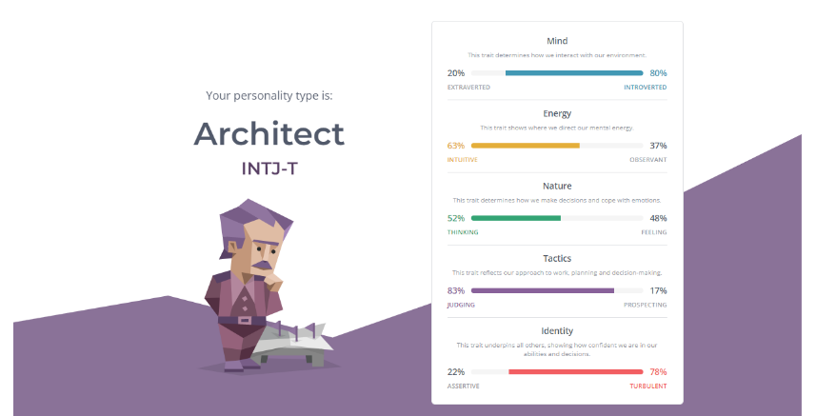

**2. Context**

I would like to work in something related to design of health care robotics. I hope that in that in this semester I can get familiar with the mechanics and control of robotic applications. Besides that, I also hope to learn about human-robot-interactions. I’m looking forward to the challenges (OL & Delta) and hope that I get paired with students that are as determined as me.

**3. Competence profile**

**Current profile**

|  |  |  |  |  |  |  |  |  |  |  |
| --- | --- | --- | --- | --- | --- | --- | --- | --- | --- | --- |
|  | Managing | Analysing | Advising | Designing | Realising |  | Future-Oriented Organisation | Investigative problem solving | Personal Leadership | Targeted Interaction |
| User interaction |  |  |  |  |  |  |  |  |  |  |
| Business processes |  |  |  |  |  |  |
| Software |  |  |  |  |  |  |
| Hardware |  |  |  |  |  |  |
| Infrastructure |  |  |  |  |  |  |

**Intended development v1**

|  |  |  |  |  |  |  |  |  |  |  |
| --- | --- | --- | --- | --- | --- | --- | --- | --- | --- | --- |
|  | Managing | Analysing | Advising | Designing | Realising |  | Future-Oriented Organisation | Investigative problem solving | Personal Leadership | Targeted Interaction |
| User interaction |  |  |  |  |  |  |  |  |  |  |
| Business processes |  |  |  |  |  |  |
| Software |  |  |  |  |  |  |
| Hardware |  |  |  |  |  |  |
| Infrastructure |  |  |  |  |  |  |

**Intended development v2**

|  |  |  |  |  |  |  |  |  |  |  |
| --- | --- | --- | --- | --- | --- | --- | --- | --- | --- | --- |
|  | Managing | Analysing | Advising | Designing | Realising |  | Future-Oriented Organisation | Investigative problem solving | Personal Leadership | Targeted Interaction |
| User interaction |  |  |  |  |  |  |  |  |  |  |
| Business processes |  |  |  |  |  |  |
| Software |  |  |  |  |  |  |
| Hardware |  |  |  |  |  |  |
| Infrastructure |  |  |  |  |  |  |

**Final development**

|  |  |  |  |  |  |  |  |  |  |  |
| --- | --- | --- | --- | --- | --- | --- | --- | --- | --- | --- |
|  | Managing | Analysing | Advising | Designing | Realising |  | Future-Oriented Organisation | Investigative problem solving | Personal Leadership | Targeted Interaction |
| User interaction |  |  |  |  |  |  |  |  |  |  |
| Business processes |  |  |  |  |  |  |
| Software |  |  |  |  |  |  |
| Hardware |  |  |  |  |  |  |
| Infrastructure |  |  |  |  |  |  |

|  |  |  |
| --- | --- | --- |
| Level 1 | Level 2 | Level 3 |

**5. KPI-table with proof**

|  |  |  |
| --- | --- | --- |
| **KPI** | **Proof** | **Rating** |
| Hardware 2.1 Analysis | * MRR: Drone part Research * EdTech: Motion Research * EdTech: Body Motion Research |  |
| Hardware 2.2 Advice | * MRR: Drone part Research |  |
| Hardware 2.3 Design | * MRR: Drone part Research * EdTech: Prototype V1.0 |  |
| Hardware 2.4 Realise | * MRR: Drone part Research * EdTech: Prototype V1.0 |  |
| Hardware 2.5 Manage | * EdTech: Prototype V1.x/V2.0 |  |
|  |  |  |
| Interaction 1.1 Analysis | * MRR: Body design * EdTech: Visual Research * EdTech: Auditory Research |  |
| Interaction 1.2 Design | * MRR: Body design * EdTech: Visual Research * EdTech: Auditory Research |  |
| Interaction 1.3 Realise | * MRR: Cap prototype * EdTech: Prototype V1.0 |  |
|  |  |  |
| Infrastructure 1.1 Analysis | * SWARM: API communication * SWARM: RF communication |  |
| Infrastructure 1.2 Advice | * SWARM: API vs RF |  |
| Infrastructure 2.3 Design | * SWARM: API communication * SWARM: RF communication * MRR: Drone communication |  |
| Infrastructure 2.4 Realise | * SWARM: API communication * MRR: Drone communication |  |
| Infrastructure 1.5 Manage | * SWARM: API communication |  |
| **Professional Development** | | |
| KPI-nr and a description Prof. Dev. |  |  |

**6. Sprint retrospectives**

After every sprint demo, you will have a retrospective. You will reflect on your process, work method and the communication within your group. Include a summary of each retrospective in this document.

Sprint 1

Sprint 2

Sprint 3

Sprint 4

Sprint 5

**7. Evaluation and Reflection**

Add an evaluation and a reflection of your whole Open Innovation semester. Your evaluation describes what went good and bad during your process and how you dealt with that. Your reflection describes how you have grown as a person, and what you will take with you in your further professional career. In the reflection you should also shine a light on the following aspects:

**Responsible**  
- Acts consciously with concern for the greater good with contemplation of relevant approaches.  
- Makes an assessment of different interests.  
**Innovativeness**  
- Focuses on renewal, improvement and making new connections.  
- Spots or creates opportunities and seizes them.  
**Resilience**  
- Challenges own ideas.  
- Perseveres in finding a result or solution.

**8. Feedpulse**

Add a screenshot of your feedpulse overview.